Student Management System Installation

After extracting the file, you will see
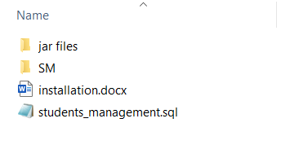

Step -1
Open your MySQL Workbench and then clink on File select New Query Tab
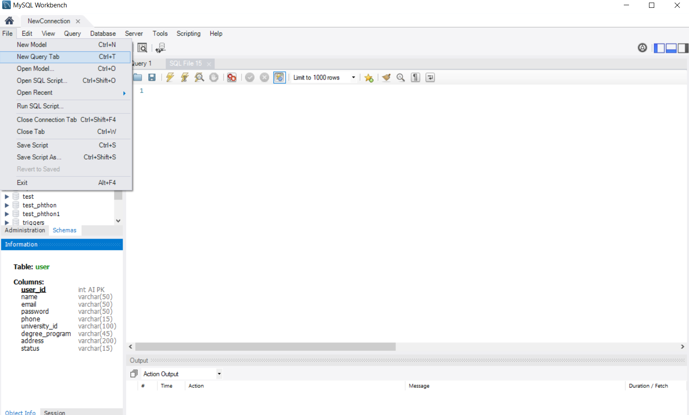

Copy all queries to the students_management.sql and paste it here. After paste all the queries click on the execute sign.
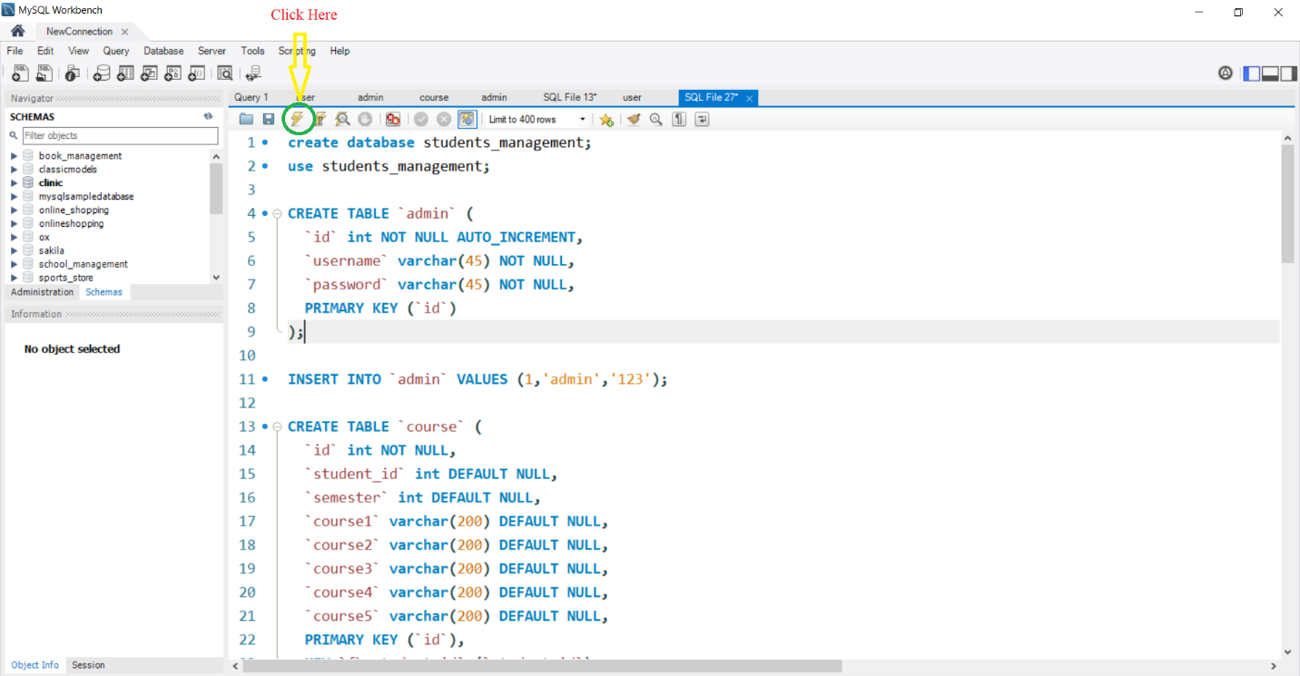
After execution database and all table will be created

Then click on the refresh sign
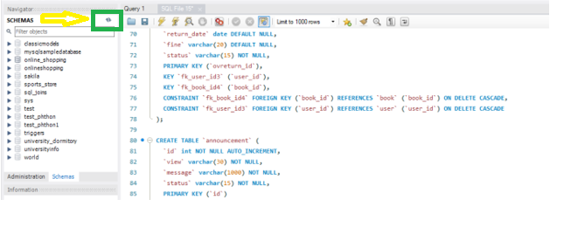
You will see all the tables in the schemas section
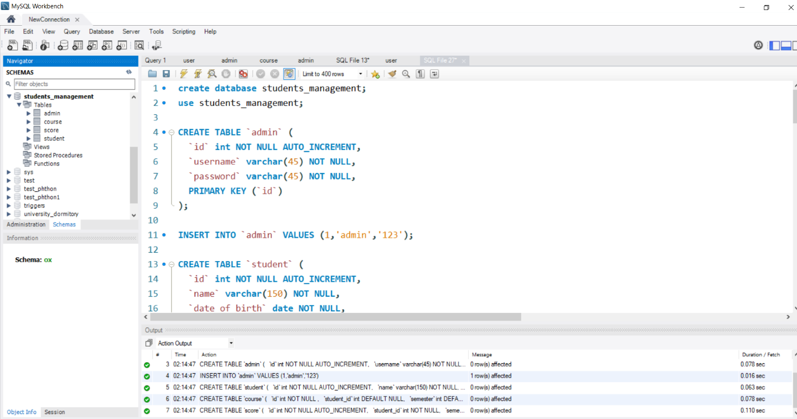

Step -2
Open your Apache NetBeans IDE. Then click File Open Project and select Student Management (SM)

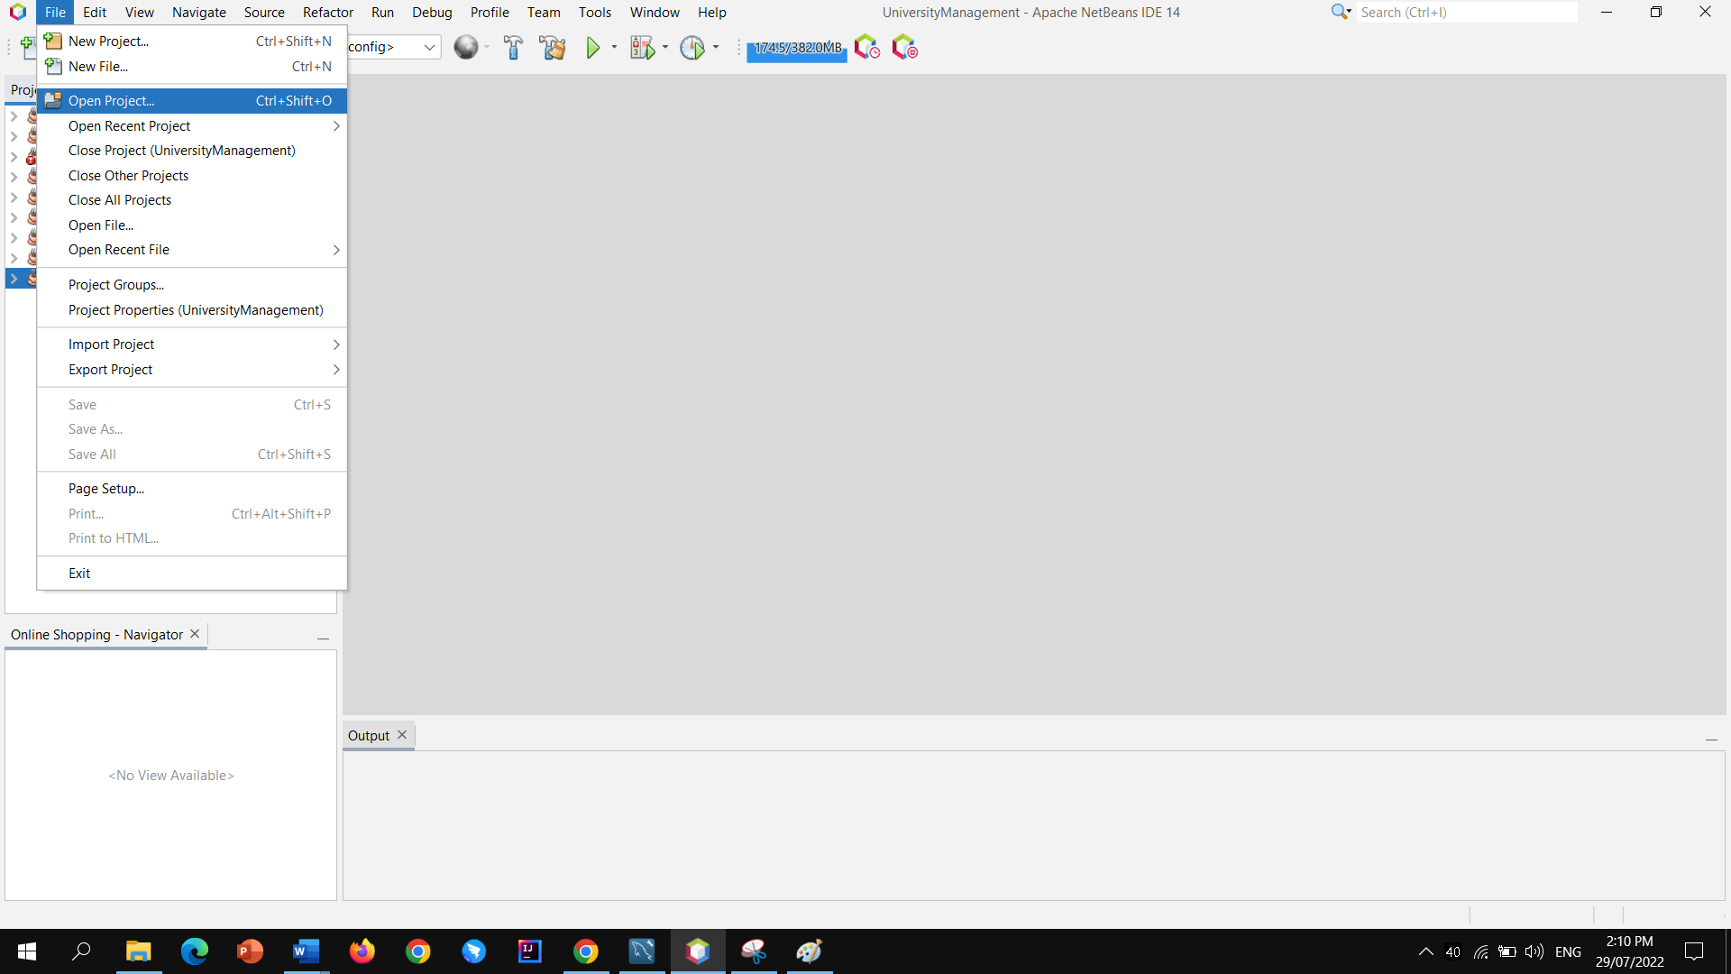

Click Open Project
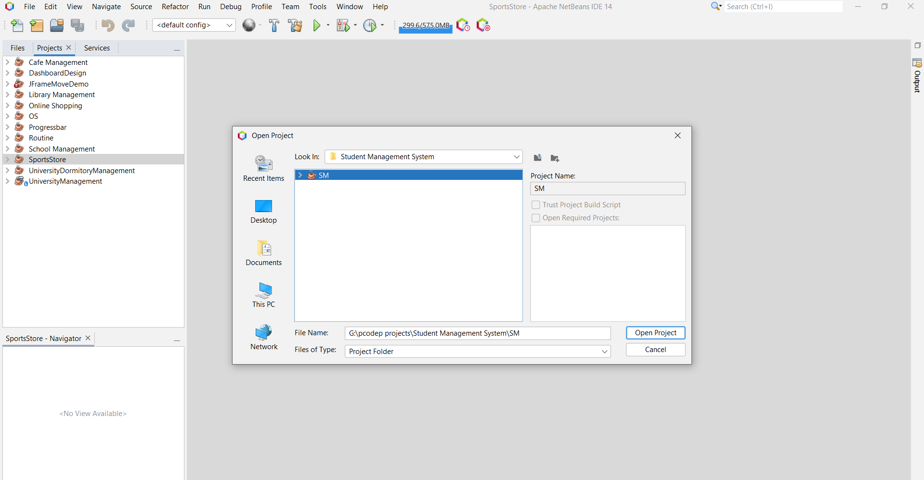

If you are getting any error pop-up message after opening the project, please follow the step

Step 2.1
Right click on the SM project and click Properties
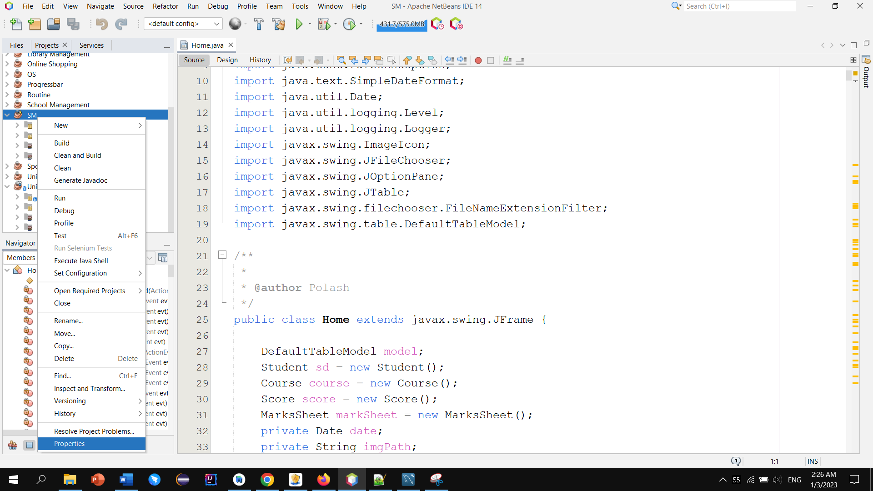

Step 2.2
Click Libraries
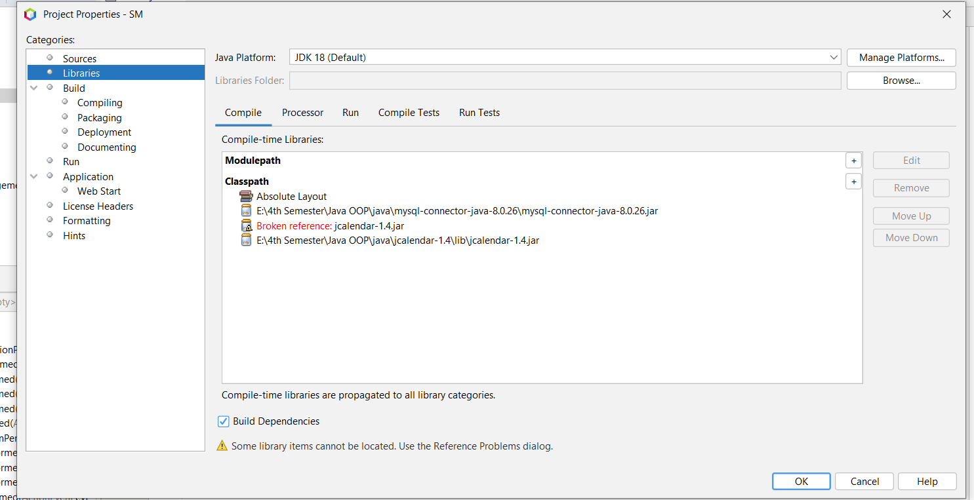

Step 2.3
Remove jCalendar1.4.jar
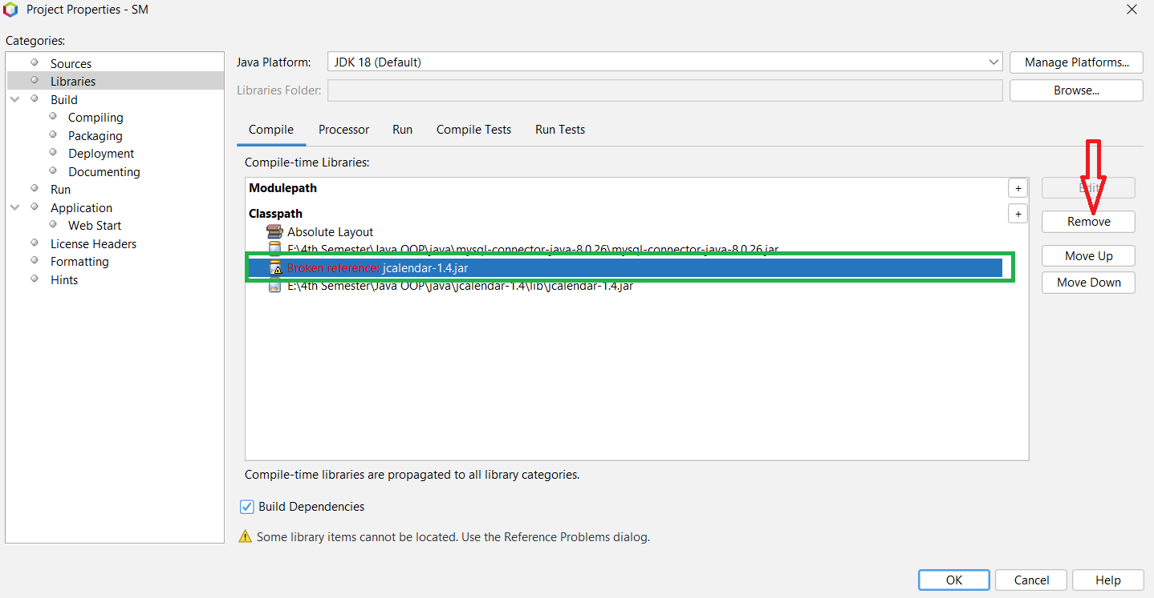

Step 2.4
After removed, you need to add jCalendar1.4.jar, click (+) icon and add jCalendar1.4.jar
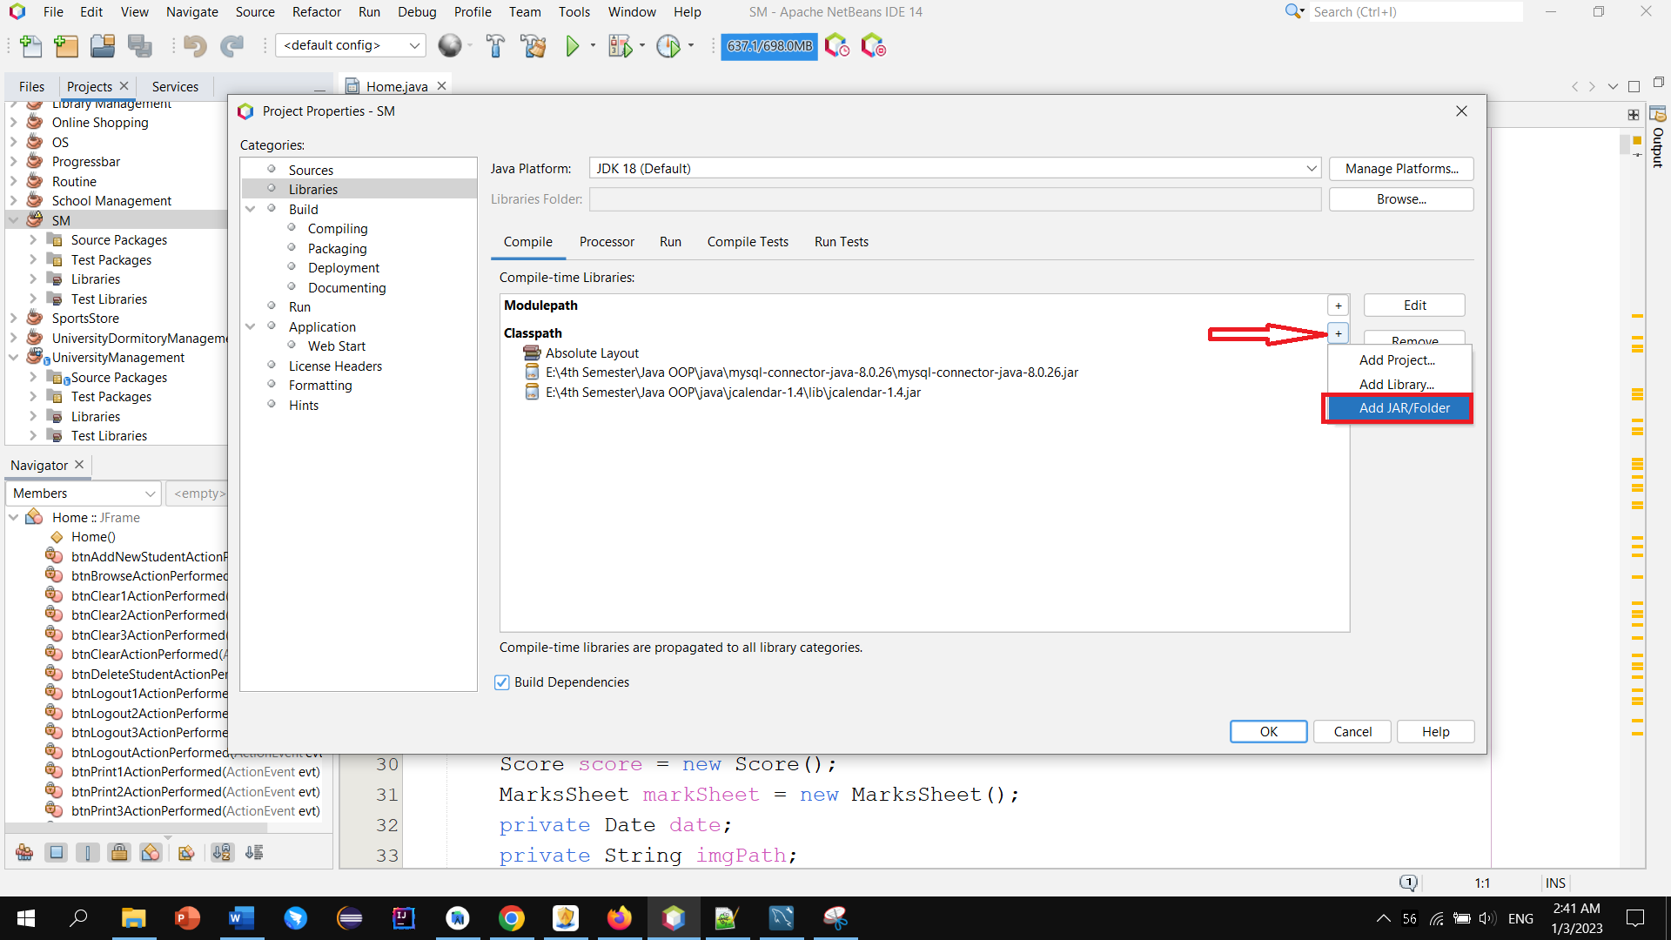

Step 2.5

Go inside jar files and click open
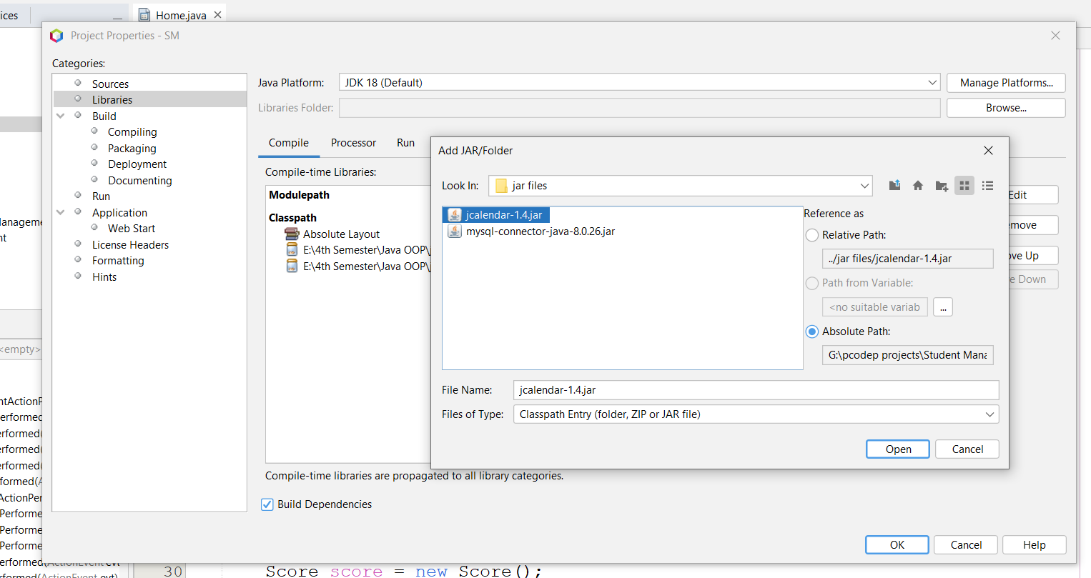

Step 2.5
Click Ok
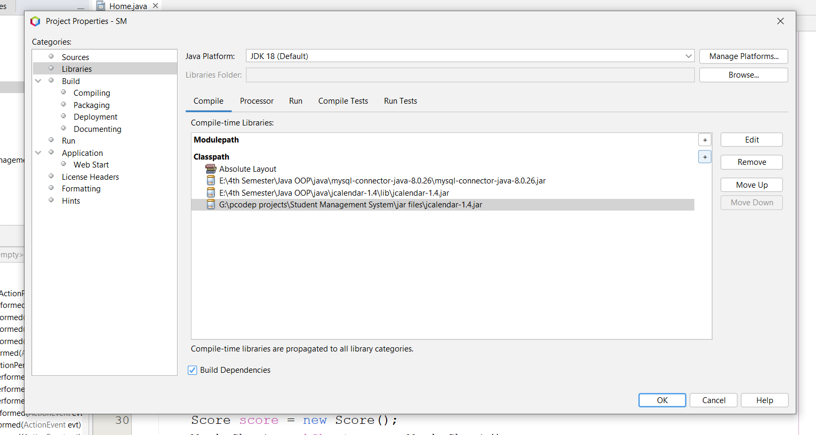

Step -3
Go to the MyConnection.java class. Here set your MySQL Workbench username and password, and run the project.
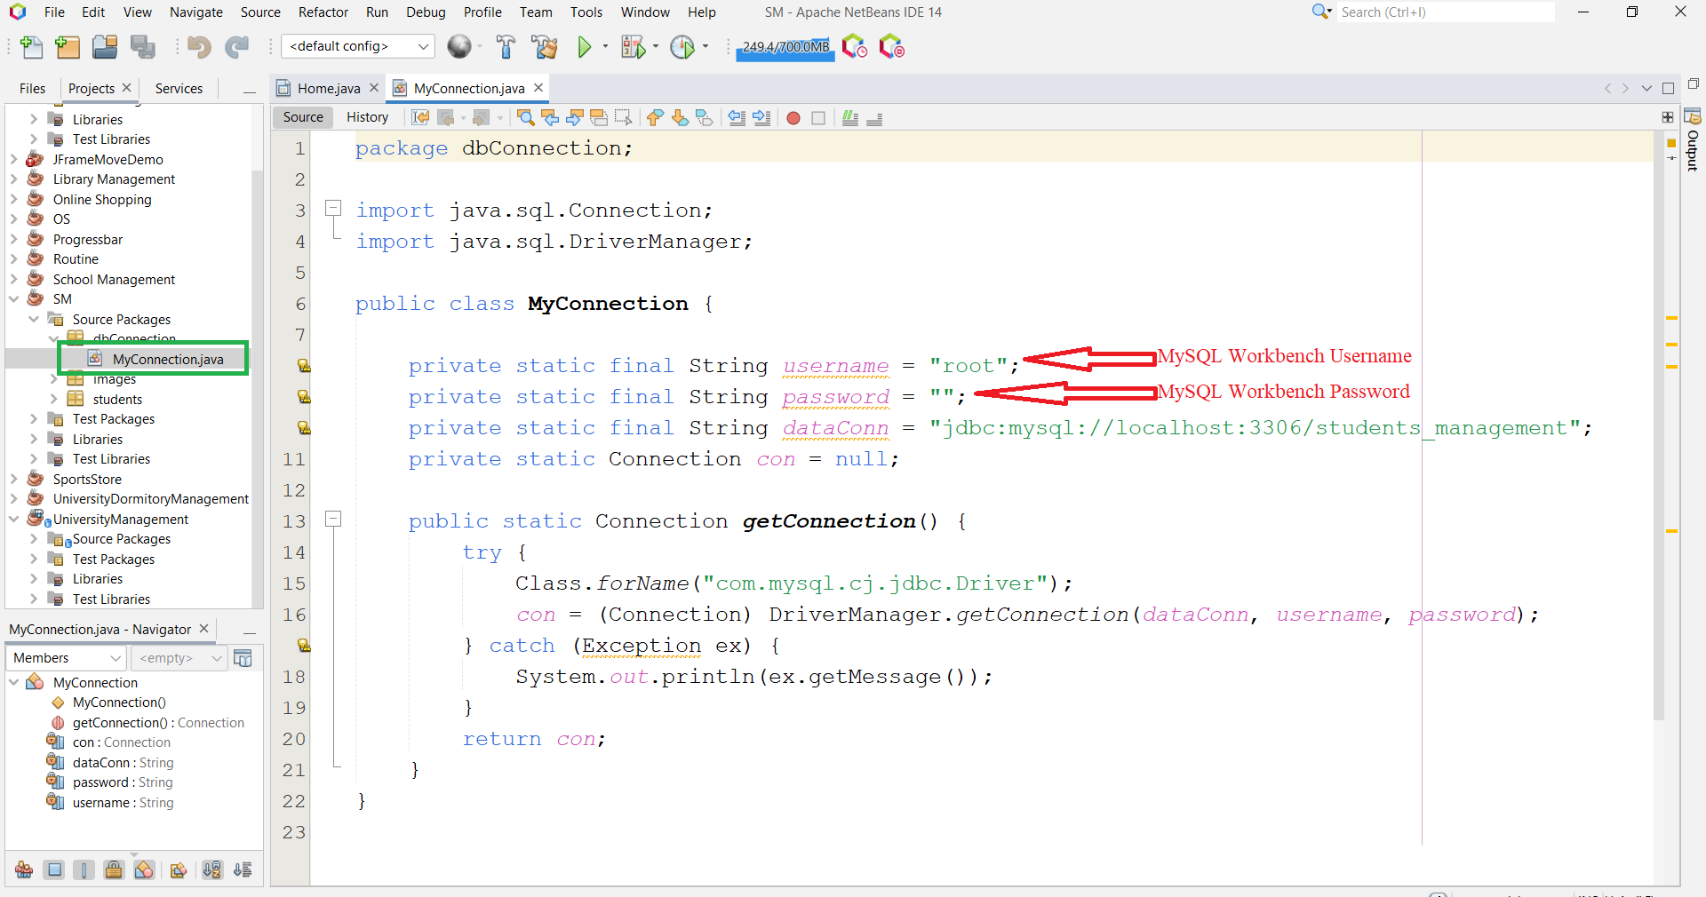

Step -4
Now You can Run the Project

If you face any problems while run the project you can contact me using email:

Thank You

